【实验题目】静态路由实验-ipv6
【实验目的】
掌握静态路由的配置和使用方法，熟悉交换机端口镜像的方法以及如何用于监视端口。
【实验内容】
完成路由器配置实验的“实例11.4 IPV6静态路由实验”，并回答问题
【实验记录】
拓扑图：
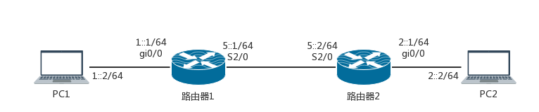
实验步骤1：
- 在主机上配置IPv6地址。
- 未配置静态路由之前，PC1与PC2不能ping通。
验证过程：在PC1的CMD中执行指令ping 2::2，效果如图所示。
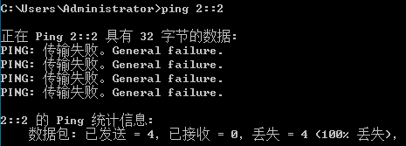
原因：PC1向IP地址为2::2的PC2发送ICMP请求数据包，当该数据包到达PC1的第一跳路由器后，路由器提取该数据包中的目的IP地址，然后查找其转发表，而转发表上没有目的IP地址为2::2的表项，该数据包将按默认路由进行转发。这就导致PC1无法ping通PC2。
- 执行show ipv6 route命令，记录路由信息，如下所示。
路由器1的路由信息：
17-RSR20-1(config)#show ipv6 route
IPv6 routing table name is - Default - 1 entries
Codes: C - Connected, L - Local, S - Static, R - RIP, B - BGP
I1 - ISIS L1, I2 - ISIS L2, IA - ISIS interarea, IS - ISIS summary
O - OSPF intra area, OI - OSPF inter area, OE1 - OSPF external type 1,
OE2 - OSPF external type 2
ON1 - OSPF NSSA external type 1, ON2 - OSPF NSSA external type 2
L ::1/128 via Loopback, local host
路由器2的路由信息：
17-RSR20-2(config)#show ipv6 route
IPv6 routing table name is - Default - 1 entries
Codes: C - Connected, L - Local, S - Static, R - RIP, B - BGP
I1 - ISIS L1, I2 - ISIS L2, IA - ISIS interarea, IS - ISIS summary
O - OSPF intra area, OI - OSPF inter area, OE1 - OSPF external type 1,
OE2 - OSPF external type 2
ON1 - OSPF NSSA external type 1, ON2 - OSPF NSSA external type 2
L ::1/128 via Loopback, local host
实验步骤2：在路由器1上配置端口的IP地址，验证路由器1端口配置，如下所示。
17-RSR20-1(config)#show ipv6 interface
interface Serial 2/0 is Up, ifindex: 2, vrf_id 0
address(es):
Mac Address: N/A
INET6: 5::1 , subnet is 5::/64
INET6: FE80::5A69:6CFF:FE27:BEAD , subnet is FE80::/64
Joined group address(es):
FF01::1
FF02::1
FF02::2
FF02::1:FF00:1
FF02::1:FF27:BEAD
MTU is 1500 bytes
ICMP error messages limited to one every 100 milliseconds
ICMP redirects are enabled
ND DAD is enabled, number of DAD attempts: 1
ND reachable time is 30000 milliseconds
ND advertised reachable time is 0 milliseconds
ND retransmit interval is 1000 milliseconds
ND advertised retransmit interval is 0 milliseconds
ND router advertisements are sent every 200 seconds<160--240>
ND router advertisements live for 600 seconds
interface GigabitEthernet 0/0 is Up, ifindex: 4, vrf_id 0
address(es):
Mac Address: 58:69:6c:27:be:ae
INET6: 1::1 , subnet is 1::/64
INET6: FE80::5A69:6CFF:FE27:BEAE , subnet is FE80::/64
Joined group address(es):
FF01::1
FF02::1
FF02::2
FF02::1:FF00:1
FF02::1:FF27:BEAD
MTU is 1500 bytes
ICMP error messages limited to one every 100 milliseconds
ICMP redirects are enabled
ND DAD is enabled, number of DAD attempts: 1
ND reachable time is 30000 milliseconds
ND advertised reachable time is 0 milliseconds
ND retransmit interval is 1000 milliseconds
ND advertised retransmit interval is 0 milliseconds
ND router advertisements are sent every 200 seconds<160--240>
ND router advertisements live for 600 seconds
解读显示的信息条目：记录中高亮的部分是我们应该关注的信息，可以看出接口Serial 2/0和GigabitEthernet 0/0处于开启状态，其中Serial 2/0接口的IPv6的地址为5::1，所在子网为5::/64；GigabitEthernet 0/0接口的IPv6的地址为1::1，所在子网为1::/64。还有自动生成的一系列组播地址和链路本地单播地址。
实验步骤3：在路由器1上配置静态路由，查看路由器1上的静态路由配置，如下所示。
17-RSR20-1#show ipv6 route
IPv6 routing table name is - Default - 11 entries
Codes: C - Connected, L - Local, S - Static, R - RIP, B – BGP
I1 - ISIS L1, I2 - ISIS L2, IA - ISIS interarea, IS - ISIS summary
O - OSPF intra area, OI - OSPF inter area, OE1 - OSPF external type 1,
OE2 - OSPF external type 2
ON1 - OSPF NSSA external type 1, ON2 - OSPF NSSA external type 2
①L ::1/128 via Loopback, local host
②C 1::/64 via GigabitEthernet 0/0, directly connected
③L 1::1/128 via GigabitEthernet 0/0, local host
④S 2::/64 [1/0] via 5::2, Serial 2/0
⑤C 5::/64 via Serial 2/0, directly connected
⑥L 5::1/128 via Serial 2/0, local host
⑦L FE80::/10 via ::1, Null0
⑧C FE80::/64 via Serial 2/0, directly connected
⑨L FE80::5A69:6CFF:FE27:BF95/128 via Serial 2/0, local host
⑩C FE80::/64 via GigabitEthernet 0/0, directly connected
⑪L FE80::5A69:6CFF:FE27:BF95/128 via GigabitEthernet 0/0, local host
分析：路由表中有静态路由信息。与步骤1中的路由表对比可知，此时的路由表不仅有静态路由信息④，而且多出了表示以太网接口0/0与子网1::/64直接相连的表项②，表示1::1/128和5::1/128是本地主机的表项③⑥，表示路由器串口2/0与子网5::/64直接相连的表项⑤。还有新增的一些链路本地单播地址信息表项⑦⑧⑨⑩⑪。
实验步骤4：配置路由器2的端口地址，验证查看端口状态，如下所示。
17- RSR20-2 (config)#show ipv6 interface
interface Serial 2/0 is Up, ifindex: 2, vrf_id 0
address(es):
Mac Address: N/A
INET6: 5::2 , subnet is 5 ::/64
INET6: FE80::5A69:6CFF:FE27:C051 , subnet is FE80::/64
Joined group address(es):
FF01:: 1
FF02:: 1
FF02:: 2
FF02:: 1:FF00:2
FF02:: 1:FF27:C051
MTU is 1500 bytes
ICMP error messages limited to one every 100 milliseconds
ICMP redirects are enabled
ND DAD is enabled, number of DAD attempts: 1
ND reachable time is 3 0000 milliseconds
ND advertised reachable time is 0 milliseconds
ND retransmit interval is 1000 milliseconds
ND advertised retransmit in terval is 0 milliseconds
ND router advertisements are sent every 200 second s<160 --240 >
ND router advertisements live for 600 seconds
interface GigabitEthernet 0/0 is Up, ifindex: 4, vrf _id 0
address(es):
Mac Address: 58:69:6c:27:c0:51
INET6: 2::1 , subnet is 2::/64
INET6: FE80::5A69:6CFF:FE27:C051 , subnet is FE8 0::/64
Joined group address(es):
FF01::1
FF02::1
FF02::2
FF02::1:FF00:1
FF02::1:FF27:C051
MTU is 1 500 bytes
ICMP error messages limited to one every 100 milliseconds
ICMP redirects are enabled
ND DAD is enabled, number o f DAD attempts: 1
ND reachable time is 30000 milliseconds
ND advertised reachable time is 0 milliseconds
ND retransmit interval is 1000 milliseconds
ND advertised retransmit in terval is 0 milliseconds
ND router advertisements are sent every 200 second s<160 --240 >
ND router advertisements live for 600 seconds
解读显示的信息条目：可以看出接口Serial 2/0和GigabitEthernet 0/0处于开启状态，其中Serial 2/0接口的IPv6的地址为5::2，所在子网为5::/64；GigabitEthernet 0/0接口的IPv6的地址为2::1，所在子网为2::/64。还有自动生成的一系列组播地址和链路本地单播地址。
有些信息与路由器1有关联，例如Serial 2/0的IPv6地址都在同一个子网5::/64，自动生成的组播地址FF02::1、FF02::2相同。
实验步骤5：配置路由器2的静态路由，验证路由器2上的静态路由配置，如下所示。
17-RSR20-2#show ipv6 route
IPv6 routing table name is - Default - 11 entries
Codes: C - Connected, L - Local, S - Static, R - RIP, B - BGP
I1 - ISIS L1, I2 - ISIS L2, IA - ISIS interarea, IS - ISIS summary
O - OSPF intra area, OI - OSPF inter area, OE1 - OSPF external type 1,
OE2 - OSPF external type 2
ON1 - OSPF NSSA external type 1, ON2 - OSPF NSSA external type 2
①L ::1/128 via Loopback, local host
②S 1::/64 [1/0] via 5::1, Serial 2/0
③C 2::/64 via GigabitEthernet 0/0, directly connected
④L 2::1/128 via GigabitEthernet 0/0, local host
⑤C 5::/64 via Serial 2/0, directly connected
⑥L 5::2/128 via Serial 2/0, local host
⑦L FE80::/10 via ::1, Null0
⑧C FE80::/64 via Serial 2/0, directly connected
⑨L FE80::5A69:6CFF:FE27:C051/128 via Serial 2/0, local host
⑩C FE80::/64 via GigabitEthernet 0/0, directly connected
⑪L FE80::5A69:6CFF:FE27:C051/128 via GigabitEthernet 0/0, local host
分析：路由表中有静态路由信息。与步骤1中的路由表对比可知，此时的路由表不仅有静态路由信息②，而且多出了表示以太网接口0/0与子网2::/64直接相连的表项③，表示2::1/128和5::2/128是本地主机的表项④⑥，表示路由器串口2/0与子网5::/64直接相连的表项⑤。还有新增的一些链路本地单播地址信息表项⑦⑧⑨⑩⑪。
实验步骤6：验证测试。
- 在主机上验证路由是否连通。
在PC1上执行指令ping 2::2，发现成功连通，如图所示。
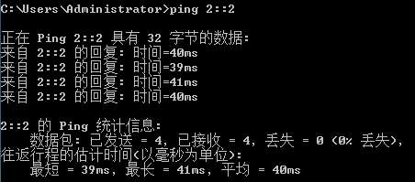
- 在主机上通过执行tracert命令查看路由情况，如图所示。
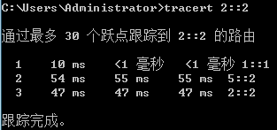
- 在2台路由器的端口0/0上各加接1台计算机，地址为3::1/64和4::1/64，画出拓扑图。在上述配置的基础上，使PC3与PC4连通，写出新增加的配置代码。
拓扑图：
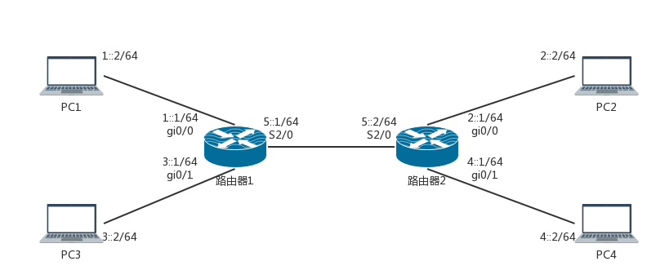
配置代码：
router1部分:
interface gigabitethernet 0/1
ipv6 address 3::1/64
ipv6 route 4::/64 serial2/0 5::2
router2部分:
interface gigabitethernet 0/1
ipv6 address 4::1/64
ipv6 route 3::/64 serial2/0 5::1

